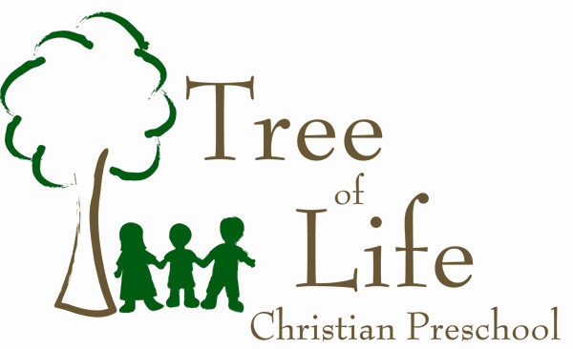

Photographic Release Form
2025-2026 School Year

I, _________________________________________, parent/guardian of _____________________________________, hereby authorize and consent to Tree of Life Christian Preschool, or any party authorized by Tree of Life Christian Preschool, to take photograph images of my child for the following purposes (please check all that apply):

_____ For classroom purposes (this includes, but not limited to, scrapbooks, art projects, pictures posted in the hallways, and on the closed group classroom photo gallery - Homeroom)

_____ For printed promotion and publicity of Tree of Life Christian Preschool (this includes, but not limited to, brochures, flyers, and other printed materials)

_____ For digital promotion and publicity of Tree of Life Christian Preschool (this includes, but not limited to, the Tree of Life Christian Preschool website and social media)

Parent or Guardian Signature

Please print your name and date

Email Address

